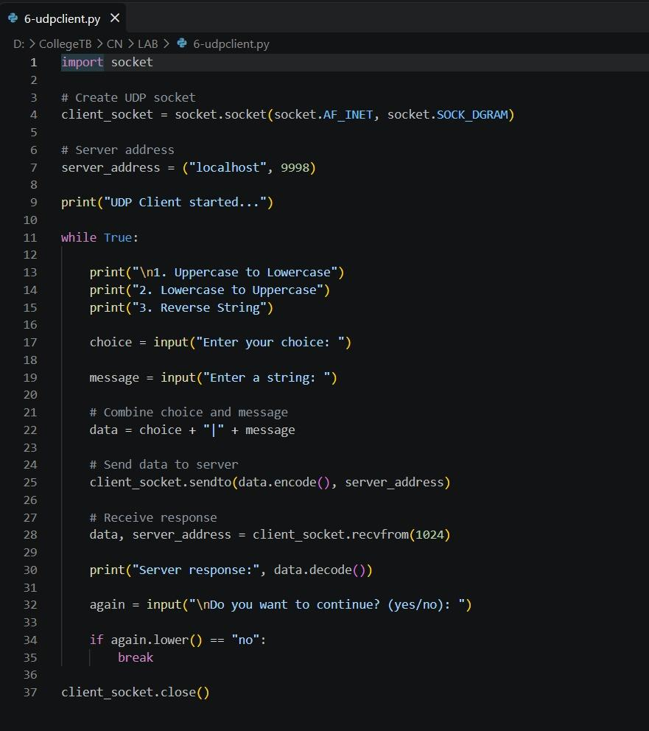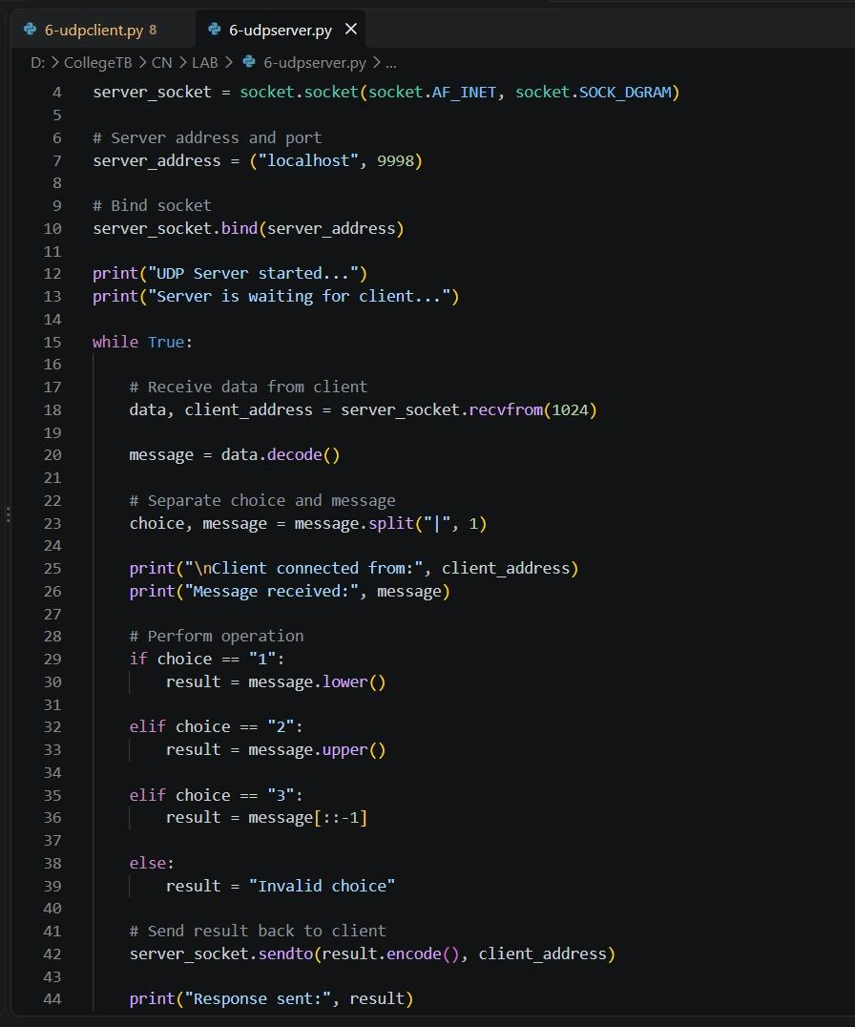
https://github.com/sakshamsinghsisodiya1204/computer-network-s-laboratory-
